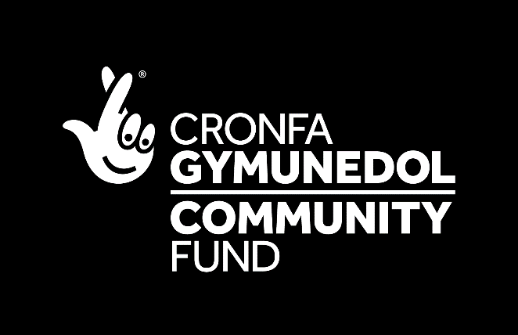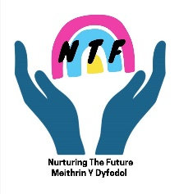

CONFIDENTIAL REFERRAL FORM FOR MIND MATTERS YOUNG PERSON SUPPORT GROUP
(FISHGUARD AND GOODWICK YOUNG PERSON’S TRUST)

NAME: |  | D.O.B:
ADDRESS: |  | CONTACT TELEPHONE NUMBER:
FIRST REFERRAL DATE: |  | RE-REFERRAL DATE:
NAME OF REFERRER:

REFERRAL METHOD
SELF: |  | PARENTS: |  | STAFF: |  | VOLUNTEER:
OTHER (SPECIFY):

REASON FOR REFERRAL
FAMILY ISSUES: |  | DEPRESSION: |  | ANGER: |  | BULLYING:
BEHAVIOUR PROBLEMS: |  | SELF-WORTH/ESTEEM: |  | SELF-IMAGE: |  | SELF HARM
EATING DISORDERS: |  | BEREAVEMENT: |  | STRESS: |  | ACADEMIC:
OTHER (SPECIFY):

NOTES

RISK FACTORS – DOES THE YOUNG PERSON PRESENT ANY RISK TO THEMSELVES OR ANOTHER PERSON THAT WE SHOULD BE AWARE OF PRIOR TO COUNSELLING?
PLEASE GIVE DETAILS BELOW:

Please email form back to Hannah Rackham Mind Matters co-ordinator at the following email address: hannahrackham@pointypt.org.uk 01348 875467

